THE AUTHORITY BUILDING ACTION PLAN
____

Introduction
Building authority is crucial for success in high-ticket affiliate marketing, where single commissions can range from $500 to several thousand dollars. Research shows that established authorities achieve conversion rates up to 5 times higher than regular affiliates. This comprehensive guide will walk you through the exact steps to build and leverage your authority status to drive premium sales.

Establishing Your Expert Position

1. Defining Your Authority Niche
Your first step is identifying your specific area of expertise where you can truly stand out.
Action Steps:
- List your top 3 areas of expertise
- Research market demand for each area (using tools like Google Trends, SEMrush)
- Analyze competition levels in each niche
- Identify underserved segments within larger markets
Exercise: Authority Niche Matrix
Create a table with the following columns:
- Expertise Area
- Market Demand (1-10)
- Competition Level (1-10)
- Your Knowledge Level (1-10)
- Profit Potential (1-10)
Choose the niche that scores highest across all categories.

2. Creating Your Authority Statement
Craft a clear, compelling statement that defines your expertise and target audience.
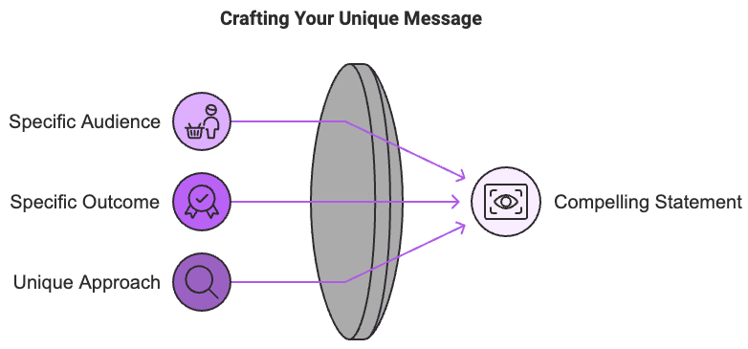
Formula:
I help [specific audience] achieve [specific outcome] through [your unique approach/methodology]
Examples:
- "I help e-commerce brands increase revenue through enterprise SEO software implementation"
- "I guide digital agencies in scaling operations using premium automation tools"

Content Strategy Development

1. Core Content Pillars
Establish 3-5 main topics that demonstrate your expertise:
Content Pillar Framework:
- Educational Content (40%)
- How-to guides
- Tutorial videos
- Case studies
- Research papers
- Thought Leadership (30%)
- Industry analysis
- Trend predictions
- Expert interviews
- Original research
- Social Proof (30%)
- Client success stories
- Implementation examples
- Results documentation
- Testimonials

2. Content Calendar Creation
Develop a systematic approach to content production:
Weekly Content Schedule:
- Monday: Long-form blog post
- Wednesday: Video content
- Thursday: Social media insights
- Friday: Newsletter/email content
- Monthly: In-depth case study or research piece
Content Planning Template:
- Topic:
- Format:
- Key Points:
- Call to Action:
- Distribution Channels:
- Promotion Strategy:

Authority Amplification Strategies

1. Digital Presence Optimization
Create a professional online presence that reflects your expertise:
Website Elements:
- Professional domain name
- Clean, modern design
- Clear value proposition
- Featured in/as seen on section
- Client results showcase
- Resources/blog section
- Professional headshots
- Contact information
Social Media Optimization:
- LinkedIn profile optimization
- Twitter professional presence
- YouTube channel setup
- Instagram business account

2. Relationship Building
Develop strategic partnerships to amplify your authority:
Partnership Categories:
- Industry Influencers
- Identify 10 key influencers
- Engage regularly with their content
- Propose collaboration opportunities
- Complementary Experts
- List potential collaboration partners
- Create joint content proposals
- Develop shared resource libraries
- Media Relationships
- Build press kit
- Pitch expert commentary
- Submit guest articles

Content Creation and Distribution

1. High-Value Content Development
Create content that establishes your expertise:
Content Types:
- Cornerstone Content
- Comprehensive guides (3000+ words)
- Industry research reports
- Definitive how-to resources
- Technology comparison guides
- Case Studies
- Client success stories
- Implementation examples
- ROI analysis
- Process documentation
- Educational Resources
- Video tutorials
- Webinar recordings
- Templates and tools
- Checklists and worksheets

2. Distribution Strategy
Maximize content reach through multiple channels:
Distribution Channels:
- Owned Media
- Website/blog
- Email newsletter
- Social media profiles
- YouTube channel
- Earned Media
- Guest posts
- Podcast appearances
- Expert interviews
- Media mentions
- Paid Media
- Sponsored content
- Social media advertising
- Retargeting campaigns
- Industry publication features

Measuring Authority Growth

1. Key Performance Indicators
Track your authority building progress:
Metrics to Monitor:
- Content Engagement
- Time on page
- Social shares
- Comments
- Email responses
- Audience Growth
- Email subscribers
- Social followers
- Website traffic
- Return visitors
- Authority Indicators
- Speaking invitations
- Media mentions
- Partnership requests
- Expert citations

2. Monthly Authority Audit
Conduct regular assessments of your authority building efforts:
Audit Checklist:
- Content performance review
- Audience growth analysis
- Engagement metrics evaluation
- Partnership development progress
- Media presence assessment
- Revenue impact analysis

Scaling Your Authority

1. Team Building
Develop support systems for sustained authority growth:
Key Roles:
- Content creation
- Social media management
- Technical support
- Administrative assistance
- Research and analysis

2. Systems and Automation
Implement tools and processes for efficiency:
Essential Tools:
- Content management system
- Social media scheduling
- Email automation
- Analytics tracking
- CRM system

Implementation Action Plan

Week 1-2: Foundation
- Complete niche analysis
- Create authority statement
- Set up tracking systems
- Develop content calendar

Week 3-4: Content Creation
- Produce cornerstone content
- Develop case studies
- Create educational resources
- Build content library

Week 5-6: Distribution
- Optimize online presence
- Implement distribution strategy
- Begin partnership outreach
- Launch newsletter

Week 7-8: Measurement and Optimization
- Track initial results
- Adjust strategies as needed
- Scale successful elements
- Plan next quarter

Conclusion
Building authority in high-ticket affiliate marketing is a systematic process that requires consistent effort and strategic implementation. By following this action plan, you'll establish yourself as a trusted expert in your niche, leading to higher conversion rates and increased commissions.
Authority building is not a sprint but a marathon. Focus on providing genuine value, maintaining consistency, and building authentic relationships within your industry. Your authority will grow naturally as you consistently demonstrate expertise and help others achieve their goals.
Start implementing these strategies today, beginning with your niche analysis and authority statement. Track your progress using the provided frameworks, and adjust your approach based on results. Your journey to becoming a recognized authority in high-ticket affiliate marketing starts now.

